Q1 display image

import cv2

import dlib

import numpy as np

img=cv2.imread('flower.jpg')

cv2.imshow('original',img)

cv2.waitkey(0)

cv2.destoryAllwindows()

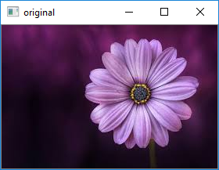

Q2 Color handling

import cv2

image=cv2.imread('face.jpg')

cv2.imshow('original',image)

cv2.circle(image,(200,85),25,(0,255,0),-1)

cv2.circle(image,(40,75),25,(0,0,255),-1)

cv2.circle(image,(110,100),50,(255,255,0),3)

cv2.imshow("test image",image)

cv2.waitKey(0)

cv2.destoryAllwindow()

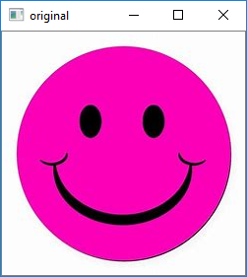 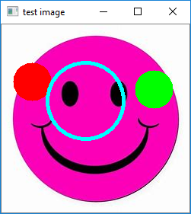

Q3 image negative

import cv2

image=cv2.imread('clown1.jpg')

cv2.imshow('original',image)

img_not=cv2.bitwise_not(image)

cv2.imshow("Negative",img_not)

cv2.waitKey(0)

cv2.destoryAllWindows()

 

Q4 Contrast stretching

import cv2

from matplotlib import pyplot as plt

img1=cv2.imread('images.jpg')

img=cv2.cvtColor(img1,cv2.COLOR_BGR2RGB)

nmax=255

nmin=0

out=cv2.normalize(img1,None,alpha=nmin,beta=nmax,norm_type=cv2.NORM_MINMAX)

plt.subplot(1,2,1),plt.imshow(img)

plt.title('original'),plt.xticks([]),plt.yticks([])

plt.subplot(1,2,2),plt.imshow(out,cmap='gray')

plt.title('output image'),plt.xticks([]),plt.yticks([])

plt.show()

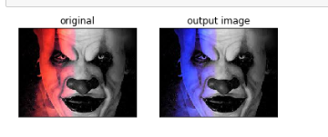

Q5Thresholding

from cv2 import *

from matplotlib import pyplot as plt

img1=cv2.imread('download.jpg')

img=cv2.cvtColor(img1,cv2.COLOR_BGR2RGB)

ret,thresh1=threshold(img1,120,255,THRESH_BINARY)

ret,thresh2=threshold(img1,120,255,THRESH_BINARY_INV)

ret,thresh3=threshold(img1,120,255,THRESH_TRUNC)

ret,thresh4=threshold(img1,120,255,THRESH_TOZERO)

ret,thresh5=threshold(img1,120,255,THRESH_TOZERO_INV)

images=[img,thresh1,thresh2,thresh3,thresh4,thresh5]

titles=["Original","THRESH_BINARY","THRESH_BINARY_INV","THRESH_TRUNC","THRESH_TOZERO","THRESH_TOZERO_INV"]

for i in range(6):

plt.subplot()

plt.imshow(images[i],cmap="gray")

plt.title(titles[i])

plt.xticks([])

plt.yticks([])

plt.show()

waitKey(0)

destroyAllWindows()

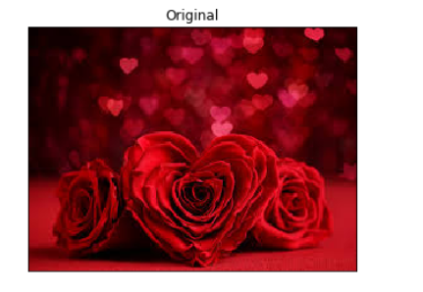

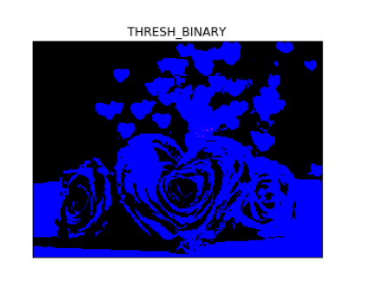

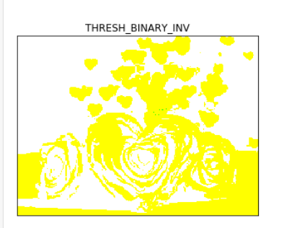 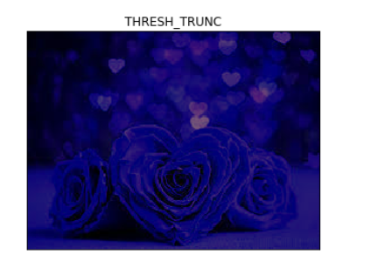 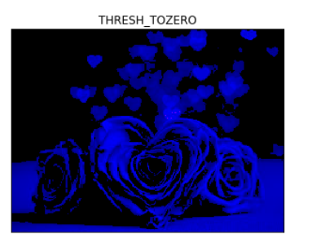 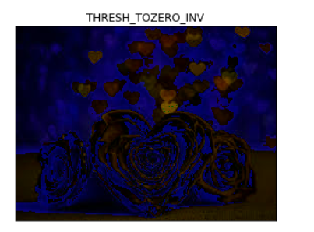

Q6 log transformation

import cv2

import numpy as np

img=cv2.imread('flower.jpg')

img_log=(np.log(img+1)/(np.log(1+np.max(img))))*255

img_log=np.array(img_log,dtype=np.uint8)

cv2.imshow('log_image',img_log)

cv2.imshow('Original',img)

cv2.waitKey(0)

cv2.destroyAllWindows()

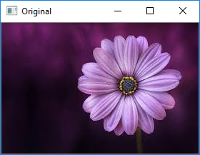 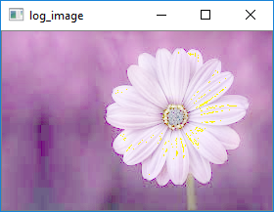

Q7 power law transformation

import cv2

import numpy as np

img=cv2.imread('boat.jpg')

cv2.imshow('Original',img)

im1=img/255.0

im_power_law_transformation=cv2.pow(im1,0.6)

cv2.imshow("power law tansformation",im_power_law_transformation)

cv2.waitKey(0)

cv2.destroyAllWindows()

